NAME: Aliza Yasin
ID: F2024065281
SECTION: W4
ASSIGNMENT: 03
GROUP PROJECT NAME: “HOSPITAL MANAGEMENT SYSTEM.”

QUESTION:01
- Context diagram:
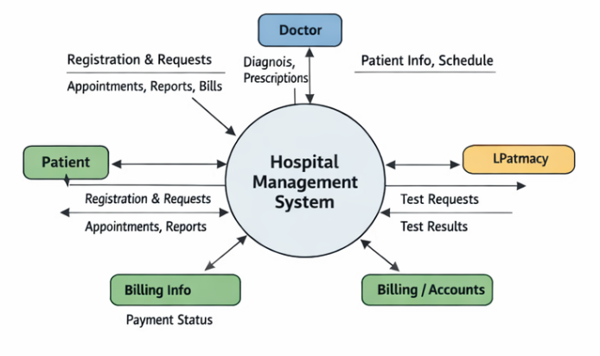

- Context Diagram into a Data Flow Diagram (DFD) Level 0:

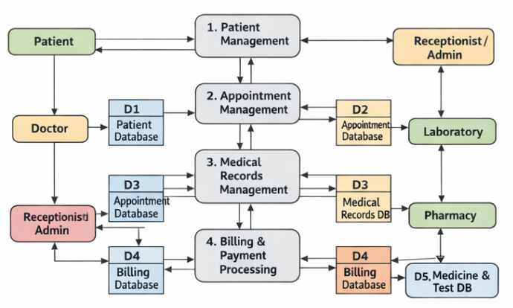

- Entity Relationship Diagram (ERD) representing the system’s data entities and their relationships.

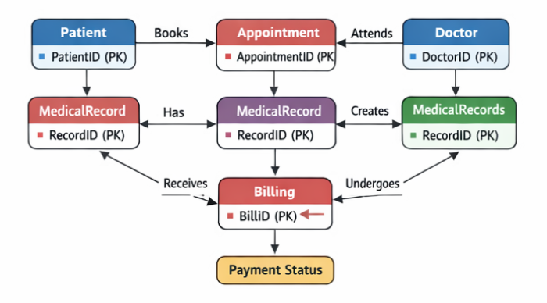
- Activity Diagram illustrating the workflow of a key process in the project.

